
American International University-Bangladesh (AIUB)
Department of Computer Science
Faculty of Science & Technology (FST)
MUSIC RECOMMENDATION SYSTEM
A Software Engineering Project Submitted
By
Semester: Summer_23_24 |  | Section: | Group Number:
SN | Student Name | Student ID | Contribution (CO3+CO4) | Individual  Marks
1 | Quazi Reshoan Yazdi | 21-45485-3
2 | Md.Nafiul Haque | 22-46355-1
3 | Hasin Mahtab Sajin | 22-46342-1
4 | Sanzida Akter Meem | 22-48030-2
5 | Jayed Hasan | 22-46364-1

The project will be Evaluated for the following Course Outcomes

CO3: Select appropriate software engineering models, project management roles and their associated skills for the complex software engineering project and evaluate the sustainability of developed software, taking into consideration the societal and environmental aspects | Total Marks
Appropriate Process Model Selection and Argumentation with Evidence | [5 Marks]
Evidence of Argumentation regarding process model selection | [5Marks]
Analysis the impact of societal, health, safety, legal and cultural issues | [5Marks]
Submission, Defense, Completeness, Spelling, grammar and Organization of the Project report | [5Marks]
CO4: Develop project management plan to manage software engineering projects following the principles of engineering management and economic decision process | Total Marks
Develop the project plan, its components of the proposed software products | [5Marks]
Identify all the activities/tasks related to project management and categorize them within the WBS structure. Perform detailed effort estimation correspond with the WBS and schedule the activities with resources | [5Marks]
Identify all the potential risks in your project and prioritize them to overcome these risk factors. | [5Marks]

Description of Student’s Contribution in the Project work

Student Name: Quazi Reshoan Yazdi
Student ID: 21-45485-3
Contribution in Percentage (%): 33.2
Contribution in the Project:
- Comprehensively writing the project proposal (1.1, 1.2)
- Choosing process model (2.1)
- Sequence Diagram (4.4)

___________________
Signature of the Student

Student Name: Md.Nafiul Haque
Student ID: 22-46355-1
Contribution in Percentage (%): 16.7
Contribution in the Project:
- Project Role Identification and Responsibilities (2.2)
- Class diagram (4.2)

___________________
Signature of the Student

Student Name:Hasin Mahtab Sajin
Student ID: 22-46342-1
Contribution in Percentage (%): 16.7
Contribution in the Project:
- Non-Functional requirements (3.3)
- State diagram (4.5)

___________________
Signature of the Student

Student Name: Sanzida Akter Meem
Student ID:22-48030-2
Contribution in Percentage (%): 16.7
Contribution in the Project:
- Project Description (3.1)
- Activity diagram (4.4)

___________________
Signature of the Student

Student Name:Jayed Hasan
Student ID: 22-46364-1
Contribution in Percentage (%): 16.7
Contribution in the Project:
- Functional Requirement (3.2)
- Use case diagram (4.1)

___________________
Signature of the Student

PROJECT PROPOSAL

Background to the Problem
Music is the most widely consumed form of content with different genres in multiple languages being enjoyed by all generations. Hence listeners generate and incredible amount of data daily. Due to the subjective nature of music understanding what a user likes has always been the question asked by record and streaming companies. Many users themselves have often faced frustration trying to find a song just like the one the listened perhaps a few days ago. Parents have had a hard time monitoring what kind of music their children listen to, furthermore failed to grasp the meaning of the lyrics that influence the way their children think and behave. This software product aims to deal with this uncertainty by answering what to listen to next.

Solution to the Problem
Project Objective:
The objective of the project is to develop a software product that addresses the challenges faced by music listeners, parents, and music industry stakeholders. Specifically, it aims to provide personalized music recommendations, help parents monitor their children's music consumption, and offer valuable insights to record labels and streaming companies.
Solutions Provided:
1. Personalized Music Recommendations: The software will track user data (age, gender, location, time, profession) and use an AI bot to understand the user's mood in real-time. The AI bot will create personalized playlists, suggest songs, and provide mental health rehabilitation resources if needed.
2. Parental Monitoring: The software will allow parents to monitor the music their children listen to using predefined criteria.
3. Music Industry Insights: The software will collect and analyze user data to provide valuable insights to record labels and streaming companies about what works and what does not work in terms of selling music.
Proposed Solutions:
1. Personalized Recommendations Using AI: The AI bot will track various user data and create personalized playlists based on the user's mood and preferences. This solution is appropriate as it leverages AI to understand the subjective nature of music preferences and provides real-time recommendations, enhancing user satisfaction.
2. Parental Monitoring Features: Parents can define criteria to monitor their children's music consumption, ensuring they are exposed to appropriate content. This solution addresses parents' concerns about their children's music influence and provides them with control over what their children listen to.
3. Data Analytics for Music Industry: The software will analyze user data to provide insights into music consumption trends, helping record labels and streaming companies make informed decisions. This solution is feasible as it offers valuable market intelligence, aligning with the business objectives of increasing music sales and engagement.
Basic Functionalities:
1. AI-Driven Personalized Recommendations: Utilizes machine learning algorithms to analyze user data and provide real-time music recommendations. Offers mental health support by suggesting rehabilitation resources if the user is in a dire mental state.
2. Parental Control and Monitoring: Allows parents to set criteria for monitoring their children's music consumption. Uses AI to analyze lyrics and content for appropriateness.
3. User Data Analytics for Music Industry: Collects and analyzes demographic and behavioral data of users. Provides insights to record labels and streaming companies on music preferences and trends.
Impact on Societal, Health, Safety, Legal, and Cultural Issues:
Societal: Enhances user experience by providing personalized music recommendations, making music discovery easier and more enjoyable.
Health: Offers mental health support by suggesting resources based on the user's emotional state, promoting well-being.
Safety: Provides parents with tools to monitor and control their children's music consumption, ensuring they are not exposed to inappropriate content.
Legal: Complies with data privacy regulations by collecting data with user consent and ensuring parental control over children's music consumption.
Cultural: Supports diverse music preferences and helps users discover music from different genres and cultures, promoting cultural appreciation and diversity.
Target Group of Users:
1. General Music Listeners: Benefit from personalized music recommendations that enhance their listening experience. Can easily find songs similar to their preferences and discover new music.
2. Parents: Benefit from the ability to monitor and control their children's music consumption. Ensure their children are exposed to appropriate content and understand the influence of lyrics.
3. Record Labels and Streaming Companies: Benefit from valuable insights into user preferences and trends. Can make informed decisions on marketing and product offerings, leading to increased sales and engagement.
Contribution to Scientific Development:
- The project contributes to the advancement of AI and machine learning in personalized content recommendation systems.
- Provides a documented case study of using AI to understand and predict user preferences in the music industry.
- Offers insights into the effectiveness of parental control mechanisms in digital content consumption.
Literature Reviews:
1. Music Recommendation Systems:
Collaborative Filtering Techniques for Music Recommendation:
Ekstrand, M. D., Riedl, J. T., & Konstan, J. A. (2011). Collaborative Filtering Recommender Systems. Now Publishers Inc.
This study provides a comprehensive overview of collaborative filtering techniques used in music recommendation systems.
Content-Based Music Recommendation:
Schedl, M., Gómez, E., Urbano, J. (2014). Music Information Retrieval: Recent Developments and Applications. Foundations and Trends in Information Retrieval, 8(2-3), 127-261.
The authors discuss the use of content-based filtering in music recommendation, focusing on analyzing audio features and metadata.
Hybrid Music Recommendation Systems:
Bonnin, G., & Jannach, D. (2014). Automated Generation of Music Playlists: Survey and Experiments. ACM Computing Surveys (CSUR), 47(2), 1-35.*
This paper surveys hybrid approaches that combine collaborative and content-based filtering for improved music recommendations.
2. Parental Control in Digital Media:
Parental Mediation of Children’s Internet Use:
Livingstone, S., & Helsper, E. J. (2008). Parental Mediation of Children’s Internet Use. Journal of Broadcasting & Electronic Media, 52(4), 581-599.
The study explores various parental mediation strategies for children's internet use, including monitoring and restrictive mediation.
Parental Control Technologies:
Symons, K., Ponnet, K., Walrave, M., & Heirman, W. (2017). A Qualitative Study into Parental Mediation of Adolescents’ Internet Use. Computers in Human Behavior, 73, 423-432.
This research examines the effectiveness of different parental control technologies and their impact on adolescents' online behavior.
Digital Parenting:
Mascheroni, G., Ponte, C., & Jorge, A. (2018). Digital Parenting: The Challenges for Families in the Digital Age. Nordic Journal of Media Studies, 1(1), 105-122.
This article provides insights into the challenges faced by parents in monitoring and controlling their children's digital media consumption.
3. User Data Analytics in the Music Industry:
Music Consumption and Data Analytics:
Schedl, M., Hauger, D., & Schnitzer, D. (2012). A Model for Serendipitous Music Retrieval. Proceedings of the 10th International Conference on Advances in Mobile Computing & Multimedia, 3-10.
The paper discusses the use of data analytics to understand music consumption patterns and enhance music retrieval systems.
Big Data in the Music Industry:
O'Dair, M., & Halliday, S. V. (2019). Music Streaming and the Role of Data. Media International Australia, 170(1), 40-50.
This study explores how big data analytics is transforming the music industry by providing insights into consumer behavior and preferences.
User Preferences in Music Streaming:
Anderson, A., Kumar, A., & Maheswaran, R. (2020). Personalized Music Recommendations Using User Data. IEEE Transactions on Knowledge and Data Engineering, 32(5), 876-888.
The authors analyze user data to develop personalized music recommendation systems that cater to individual preferences.
Utilization and Extension of Existing Studies:
- Real-Time Mood Analysis: This project builds on existing recommendation system research by incorporating real-time mood analysis using AI.
- Enhanced Parental Control: Extends parental control mechanisms by integrating AI-driven content analysis and monitoring features.
- Comprehensive Analytics: Enhances user data analytics by providing a comprehensive solution that benefits both users and industry stakeholders.
Existing Software Solutions:
Spotify: Uses collaborative filtering and content-based filtering to recommend music to users but lacks real-time mood analysis and parental control features.
YouTube Kids: Provides parental control features to monitor and control children's video consumption but does not focus on music recommendations.
Apple Music Analytics: Offers insights into user preferences and trends for artists and record labels but does not offer personalized recommendations or parental control.
Extension of Existing Solutions:
Real-Time Mood Analysis: The proposed solution extends existing recommendation systems by incorporating AI-driven real-time mood analysis.
Parental Control: Enhances parental control features by allowing parents to set criteria and monitor music consumption.
Comprehensive Analytics: Provides a unified solution that offers personalized recommendations, parental control, and user data analytics, benefiting users and industry stakeholders alike.

SOFTWARE DEVELOPMENT LIFE CYCLE

Process Model
- Music recommendation system uses machine learning (ML) to develop a recommendation to the user. This system is dynamic, requires frequent updates based on user preferences and evolving music trends. Collaboration among team members is essential to enhance recommendation algorithms and user experience.
- A hybrid approach combining Scrum and Extreme Programming (XP) is chosen because:
  - Scrum provides structure with its iterative sprints, allowing incremental development and adaptability.
  - XP’s emphasis on testing and continuous integration ensures robust algorithms, code quality, customer involvement, and collaboration through practices like pair programming.
- Traditional methods such as Waterfall, V-shaped and Spiral model were not chosen because:
  - Waterfall Model:
    - Lack of Flexibility: Waterfall’s rigid sequential nature makes accommodating changes or evolving requirements challenging.
    - Limited Adaptability: It’s less suited for dynamic environments where quick adaptations are necessary.
  - Spiral model:
    - Complexity: While suitable for complex projects, it may introduce unnecessary overhead for ML development.
    - Adaptability: The spiral model’s adaptability depends on the risk assessment, which might not align with ML-specific challenges.
  - V-shaped model:
    - ML models require continuous training and evaluation, which doesn’t align neatly with the V-shaped approach.
    - Rigidity in testing phases may hinder quick adjustments based on user feedback.
- Agile methods such as Dynamic Systems Development Method (DSDM) and Feature Driven Development method (FDD):
  - FDD:
    - ML projects often involve complex algorithms, not easily broken down into discrete features.
    - FDD’s feature-centric nature might not map well to ML model training and evaluation.
    - Lack of ML-Specific Practices: FDD lacks specific practices for ML quality assurance and continuous integration.
  - DSDM:
    - DSDM is suitable for projects with clear business goals, stable requirements, and a focus on delivering business value. Music recommendation system, being dynamic and ML-driven, may not fit this profile.
    - Rigidity: DSDM has predefined phases (feasibility, business study, functional model iteration, etc.), which might limit adaptability to evolving ML algorithms.
    - Emphasis on Documentation: DSDM requires extensive documentation, which may not align with agile ML development.

Project Role Identification and Responsibilities
In developing our Music Recommendation System, we embraced Agile principles through Scrum and Extreme Programming (XP), ensuring dynamic responsiveness and iterative progress. Led by a dedicated Product Owner, we define a clear vision and prioritize features that resonate with our users and stakeholders. Supported by a proactive Scrum Master, our development team collaborates fervently to deliver high-quality software increments. Quality Assurance guarantees rigorous testing, maintaining reliability and user satisfaction. External stakeholders, including users, domain experts, and management, provide essential feedback and strategic direction, guiding us towards a system that excels in both functionality and user experience. We can divide roles into two parts Internal and External stakeholders:

Internal Stakeholders:
  - Product Owner (PO)
  - Scrum Master
  - Development Team
  - Quality Assurance (QA) Team

External Stakeholders:
  - Users
  - Stakeholders
  - Domain Experts
  - External Suppliers or Vendors
  - Management

Here are the responsibilities of the role in the Music Recommendation System:
- Internal Stakeholders:
  - Product Owner (PO):
- Define Product Vision: Develop a clear understanding of what the Music Recommendation System should achieve and articulate this vision to the team.
- Manage Product Backlog: Prioritize features and user stories based on business value, ensuring the most valuable items are delivered first.
- Stakeholder Management: Gather and synthesize feedback from stakeholders (users, management, domain experts) to refine and adjust the product backlog accordingly.
- Decision Making: Make timely decisions regarding feature prioritization, scope changes, and project direction to maximize the product's value.
- Scrum Master:
- Facilitate Scrum Events: Organize and facilitate sprint planning, daily stand-ups, sprint reviews, and retrospectives to ensure effective communication and collaboration within the team.
- Remove Impediments: Identify and remove obstacles that hinder the team's progress, whether they are technical, organizational, or interpersonal.
- Coach and Mentor: Guide the team in Agile practices and principles, fostering a culture of continuous improvement and self-organization.
- Shield the Team: Protect the team from external distractions and disruptions, allowing them to focus on delivering high-quality increments during each sprint.
- Development Team:
- Implement Features: Develop and implement software features and functionalities according to the specifications and acceptance criteria defined for each sprint.
- Collaborate: Participate actively in sprint planning, daily stand-ups, and sprint reviews to share progress, discuss challenges, and adjust plans as needed.
- Testing and Quality Assurance: Ensure code quality through rigorous testing practices, including unit testing, integration testing, and collaboration with QA to address bugs and issues promptly.
- Continuous Improvement: Continuously seek opportunities to improve the product, processes, and teamwork based on feedback and retrospective findings.
- Quality Assurance (QA) Team:
- Test Planning: Develop comprehensive test plans and strategies based on user stories and acceptance criteria defined by the Product Owner.
- Execute Testing: Conduct various types of testing, including functional, usability, performance, and regression testing, to verify that the Music Recommendation System meets quality standards.
- Defect Management: Identify, report, and track defects throughout the development lifecycle, collaborating closely with the development team to resolve issues promptly.
- Feedback Loop: Provide feedback to the development team on test results, usability findings, and overall product quality to support iterative improvements.
- External Stakeholders:
- Users:
  - Feedback and Validation: Provide feedback on the usability, functionality, and performance of the Music Recommendation System through user testing and usage.
  - User Acceptance Testing: Participate in user acceptance testing (UAT) sessions to validate that the system meets their needs and expectations before deployment.
  - Feature Prioritization: Express preferences and priorities regarding new features or improvements based on their experience with the system.
  - Stakeholders (Customers, Sponsors, Executives):
    - Requirement Elicitation: Communicate business requirements and expectations to the Product Owner, ensuring alignment with strategic goals and customer needs.
    - Project Advocacy: Support the project by advocating for necessary resources, budget allocations, and organizational support to ensure successful delivery
    - Risk Management: Identify potential risks or challenges that may impact project outcomes and collaborate with the team to mitigate them effectively.
  - Domain Experts:
    - Technical Guidance: Provide expertise in specialized areas such as music recommendation algorithms, UX design, or backend architecture to inform technical decisions and enhancements.
    - Best Practices: Recommend industry best practices and emerging trends relevant to the Music Recommendation System to optimize performance and user experience.
    - Prototype Evaluation: Evaluate prototypes and early releases to provide feedback on technical feasibility, performance metrics, and alignment with domain-specific requirements.
  - External Suppliers or Vendors:
    - Integration Support: Collaborate with the project team to integrate third-party tools, APIs, or components into the Music Recommendation System, ensuring seamless functionality and compatibility.
    - Service Level Agreement (SLA) Compliance: Ensure adherence to contractual agreements and SLAs regarding service delivery, support, and maintenance of external components.
    - Technical Support: Provide technical support and troubleshooting assistance related to integrated components throughout the project lifecycle.
  - Management:
- Strategic Direction: Define and communicate strategic goals and objectives for the Music Recommendation System project, aligning with organizational priorities.
- Resource Allocation: Allocate budget, manpower, and other resources necessary for project execution and successful delivery.
- Decision Making: Make critical decisions regarding scope changes, risk management, and project prioritization based on project progress and stakeholder input.
- Identify all the roles/stakeholder in the software/project management activities in software development.
- Describes the responsibilities of the role in the software development.

3. Project description and Requirements:

3.1 Project Description
Music recommendation system is a stand alone application that can automatically suggest the next music to listen to. Users can login and register using their own email or directly log in or register through Google, Apple Music or Spotify and automatically connect their music streaming data to the application. The application is simple to use as once it is activated, it seamlessly runs in the background. The application uses a federated learning which is a decentralized model that ensures data privacy. The model is trained locally on the users device, it learns the users music listening habits taking into consideration, age, gender, location, tier of streaming service, time. The built in AI bot periodically suggests different playlists based on the training. Using user feedback the model keeps improving. One of the premier features is parental control, children under the age of 16 will be monitored to make sure that songs with certain unsavory vocabulary, explicit content and misleading meaning are restricted and better alternatives are suggested based on parents preference. The user can also vaguely describe a song in a chat box and the AI bot will try to guess the name of the song accurately.

3.2 Functional Requirements:
- Sign Up:
  - Email and Password Registration:
    - Users can create an account using their email address and set a password.
- Register:
  - Third-Party Integration:
    - Users can register and log in using Google, Apple Music, or Spotify accounts.
    - Upon registration, the application connects and imports user data from the respective music streaming service.
- Log In:
  - Email and Password Authentication:
    - Users can log in to the application using their registered email and password.
  - Third-Party Authentication:
    - Users can log in using their Google, Apple Music, or Spotify credentials.
- Parental Control:
  - Content Monitoring:
    - The application monitors music for users under the age of 16.
  - Explicit Content Restriction:
    - Songs with unsavory vocabulary, explicit content, and misleading meanings are restricted.
  - Alternative Suggestions:
    - The AI suggests alternative songs based on parents' preferences.
- Curated Playlist:
  - Personalized Playlists:
    - The AI bot creates and suggests playlists based on the user’s listening habits, demographics, and feedback.
- AI Chat Bot:
  - Song Identification:
    - Users can describe a song in a chat box, and the AI bot attempts to identify the song.
  - Music Recommendations:
    - The AI bot suggests music based on user inputs and preferences.
- Feedback:
  - User Feedback Collection:
    - Users can provide feedback on the playlists and song suggestions.
  - Model Improvement:
    - The AI uses user feedback to continuously improve the recommendation model.
- Connected Accounts:
  - Music Streaming Data Integration:
    - The application integrates with Google, Apple Music, and Spotify to access users' streaming data.
  - Seamless Background Operation:
    - Once activated, the application runs in the background, updating user data and recommendations.
- Curated Suggestions:
  - Periodic Recommendations:
    - The AI bot periodically suggests playlists and songs based on the user's listening habits and feedback.
- Music Search:
  - Song Search:
    - Users can search for songs within the application’s database.
  - Vague Description Search:
    - Users can provide a vague description of a song, and the AI bot will attempt to identify it.

3.3 Non-Functional Requirements:
- Data Privacy:
  - Federated Learning:
    - Ensures that user data is processed locally on their devices, preserving privacy and reducing the risk of data breaches.
- Performance:
  - Real-Time Processing:
    - The application should process user data and provide recommendations in real-time without noticeable delays.
  - Background Operation:
    - The application should seamlessly run in the background without affecting the device’s performance.
- Scalability:
  - Handling Multiple Users:
    - The application should efficiently handle a large number of users and their data.
  - Elastic Scaling:
    - The system should scale resources up or down based on the number of active users.
- Usability:
  - User-Friendly Interface:
    - The application should have an intuitive and easy-to-navigate user interface.
  - Easy Integration:
    - Simple processes for logging in, registering, and connecting to third-party accounts.
- Reliability:
  - Uptime and Availability:
    - The application should have high availability and minimal downtime to ensure continuous access for users.
  - Error Handling:
    - Robust mechanisms for detecting, logging, and resolving errors or issues within the application.
- Security:
  - Secure Authentication:
    - Implement strong authentication mechanisms to protect user accounts.
  - Data Encryption:
    - Ensure all data, especially personal and sensitive information, is encrypted both in transit and at rest.
- Maintainability:
  - Modular Design:
    - The application should be designed in a modular manner to facilitate easy updates and maintenance.
  - Documentation:
    - Comprehensive documentation for all features and functionalities to assist in future development and troubleshooting.
- Compliance:
  - Regulatory Adherence:
    - Ensure the application complies with relevant data protection regulations (e.g., GDPR, CCPA).

4. System Design Specification

4.1 USE CASE DIAGRAM:

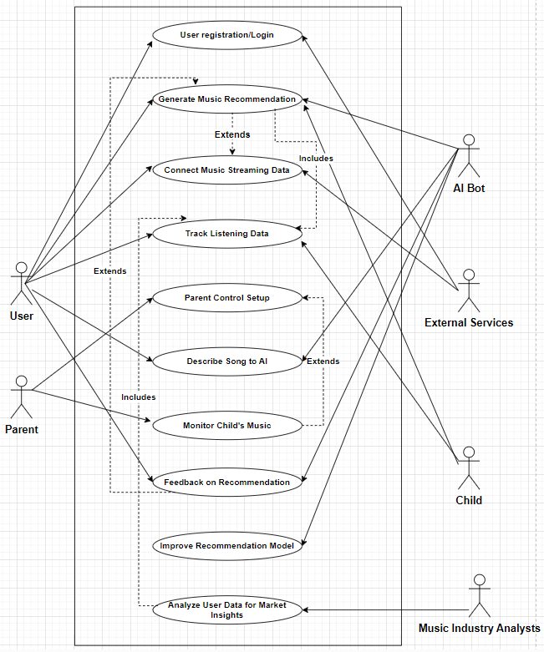

4.2 CLASS DIAGRAM:

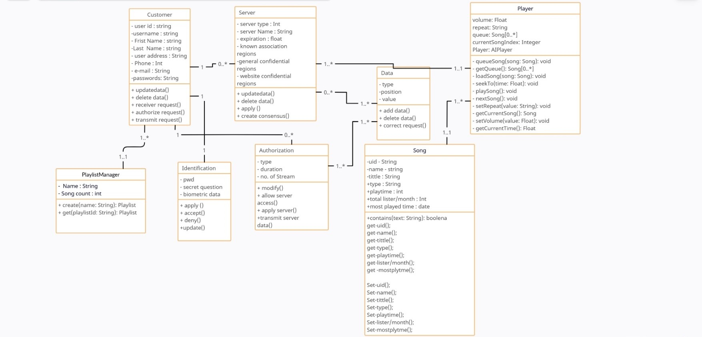

4.3 SEQUENCE DIAGRAM:

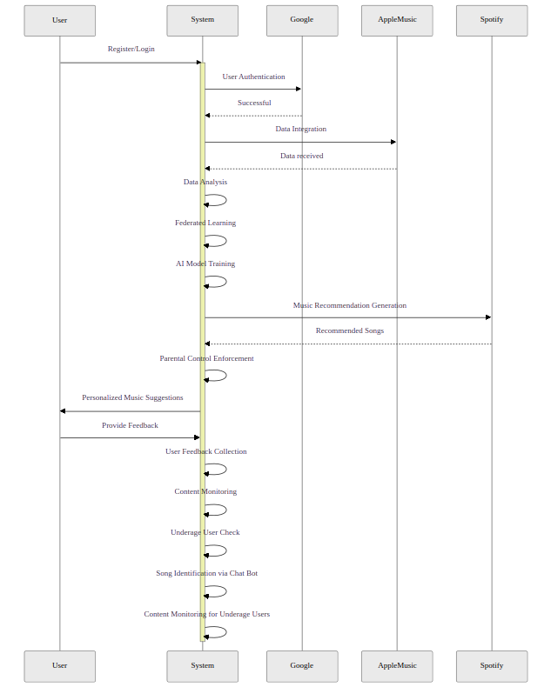

4.4 ACTIVITY DIAGRAM:

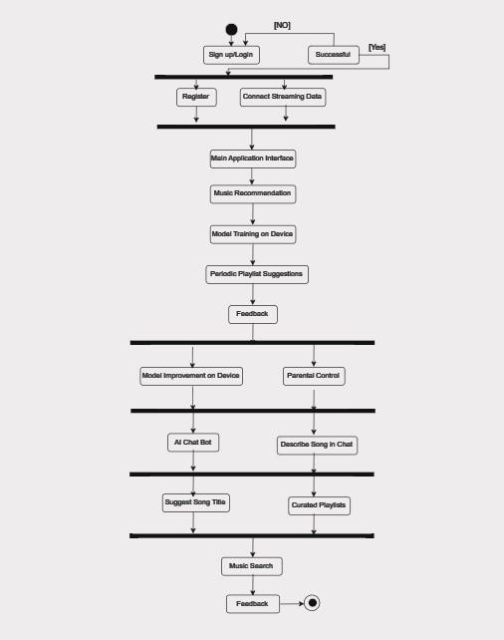

4.5 STATE DIAGRAM

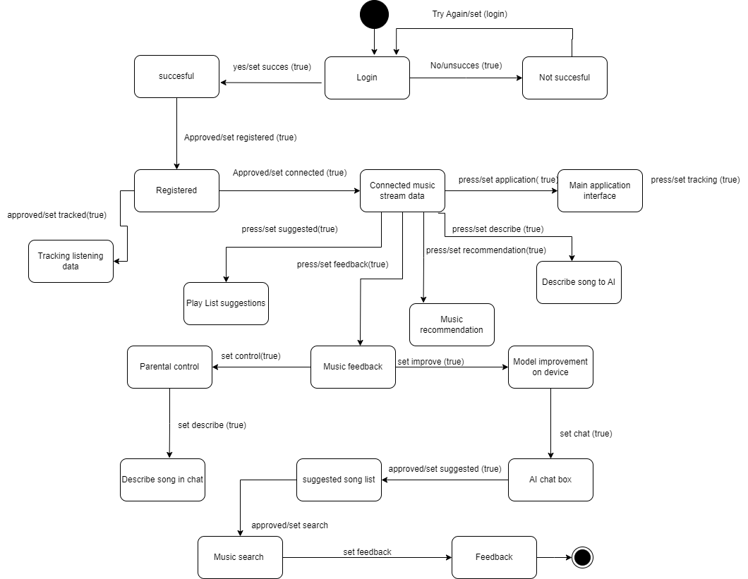

Rubric for Project Assessment (CO3)
Criteria | Marks distribution (Max 3X5= 15) |  |  |  | Acquired  Marks
 | Inadequate (1-2) | Satisfactory (3) | Good (4) | Excellent (5)
Selection of Software Engineering Models | Does not articulate a position or argument of choosing appropriate model. Does not present any evidence to support the arguments for the choice of the model | Articulates a position or argument for choosing models that is unfocused or ambiguous. Presents incomplete/vague evidence to support argument for model choice | Articulates a position or argument of choosing models that is limited in scope. Does not present enough evidence to support the argument for the choice of the model | Clearly articulates a position or argument for the choosing software engineering models. Presents sufficient amount of evidence to support argument for the model selection
Role identification and Responsibility Allocation | The project has poor project management plans for identifying roles and assigning the responsibilities | Identify few roles in the project management where some of the roles are left alone with any project responsibilities | Identify most of the roles in the project management and assign their responsibilities | Well planned project with proper role identification and responsibility allocation in the project management activities
Impact identification
Formatting and Submission | Project report is not complete and Several errors in spelling and grammar. Present a Confusing organization of concepts, supporting  arguments, and  real-life example.  Sentences rambling, and details are repeated. | Some errors in spelling and grammar. Some problems  of organizing the answer in a logical order of defining,  elaborating, and providing real-life examples. | Few errors in spelling and grammar. Presents most of the details in a logical flow of  organization in  definition,  details, and  example. | Project report is complete and No errors in spelling and grammar. Consistently  presents a logical  and effective  organization of definition,  details, and real-life example of  the topic.
Acquired marks:
CO Pass / Fail:

Rubric for Project Assessment (CO4)
Marking Criteria | Marks Distribution (Maximum 3X5=15) |  |  |  | Acquired Marks
 | Inadequate (1-2) | Satisfactory (3) | Good (4) | Excellent (5)
Project Planning | No background information regarding the project is  given; project goals and benefits are  missing. | Insufficient background information is given; project goals and benefits are  poorly stated | Sufficient background information is given; the purpose and goals of the project are explained. | Thorough and relevant background information  is given; project goals are clear and easy to identify.
Effort Estimation and Scheduling | Student vaguely discuss the impact of societal, health, safety, legal and cultural issues in their project | Student provided with partial relevance to the impact of societal, health, safety, legal and cultural issues in their project | Student fairly provided the analysis to the impact of societal, health, safety, legal and cultural issues in their project | Student comprehensively provided the analysis to the impact of societal, health, safety, legal and cultural issues in their project
Risk Management | Ambiguous representative example. | Partially identify / indicate towards real-life example. | Real-life example is fairly connected towards the definition. | Comprehensively defend with real life example.
Acquired Marks:
CO Pass / Fail:

